|  |  |
| --- | --- |
| 20ITR012 | ASIFAA SULTHANA N |
| 20ITR024 | FAHIMA BEGUM B |

**HOME PAGE:**

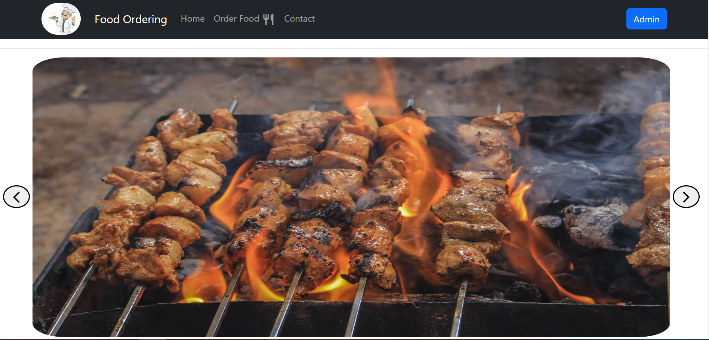

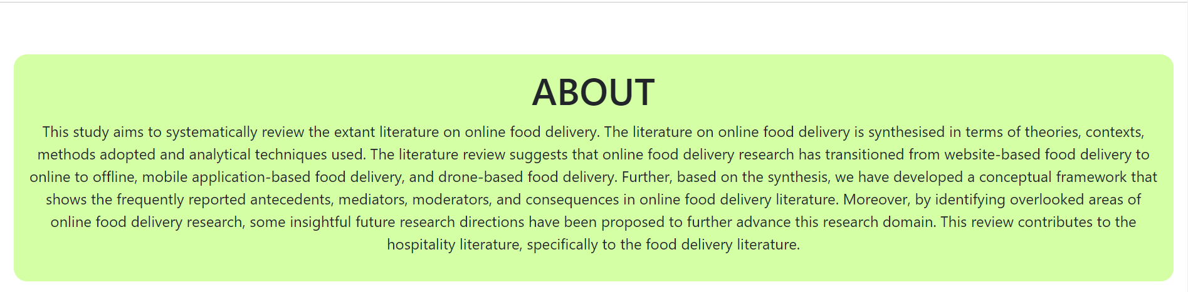

**ADMIN PANEL:**

**LOGIN:**



**ADD FOOD:**

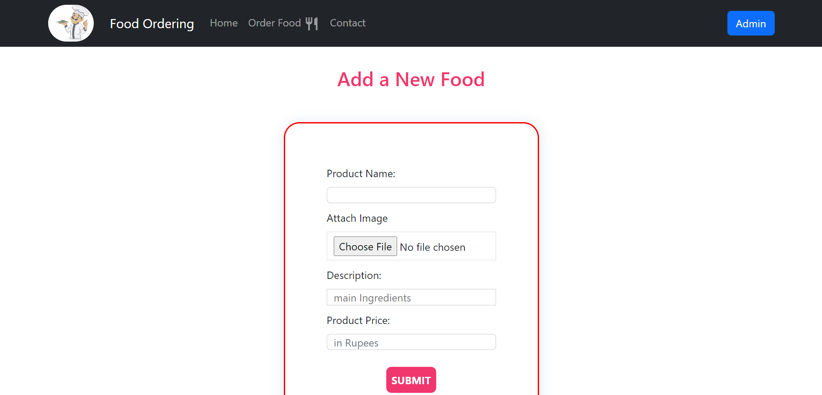

**ADD NEW ADMIN:**



**ORDER FOOD:**

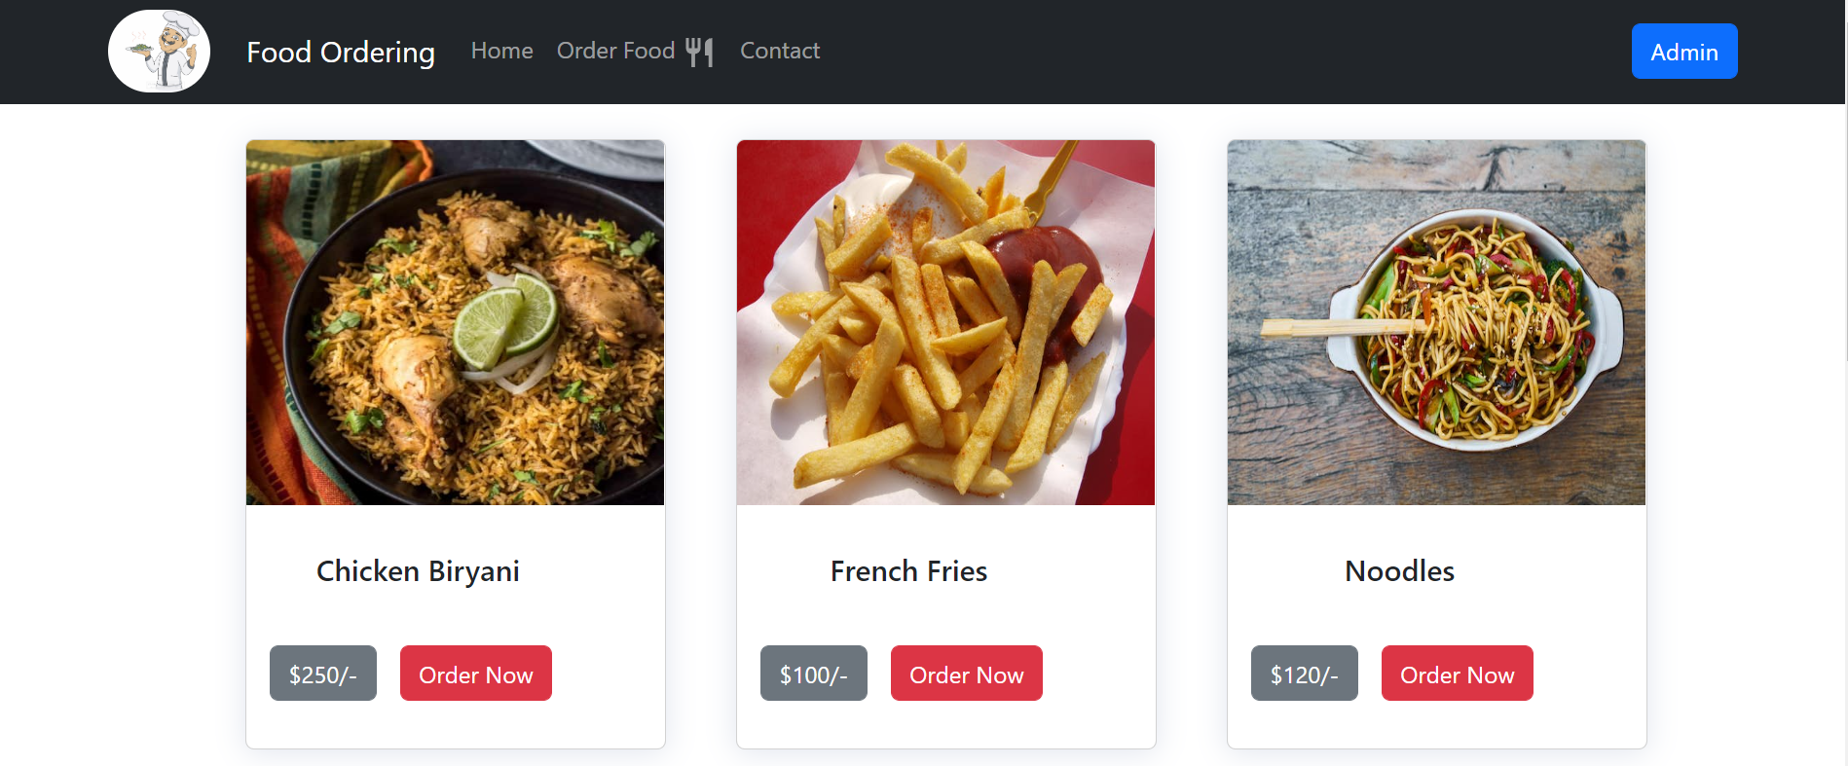

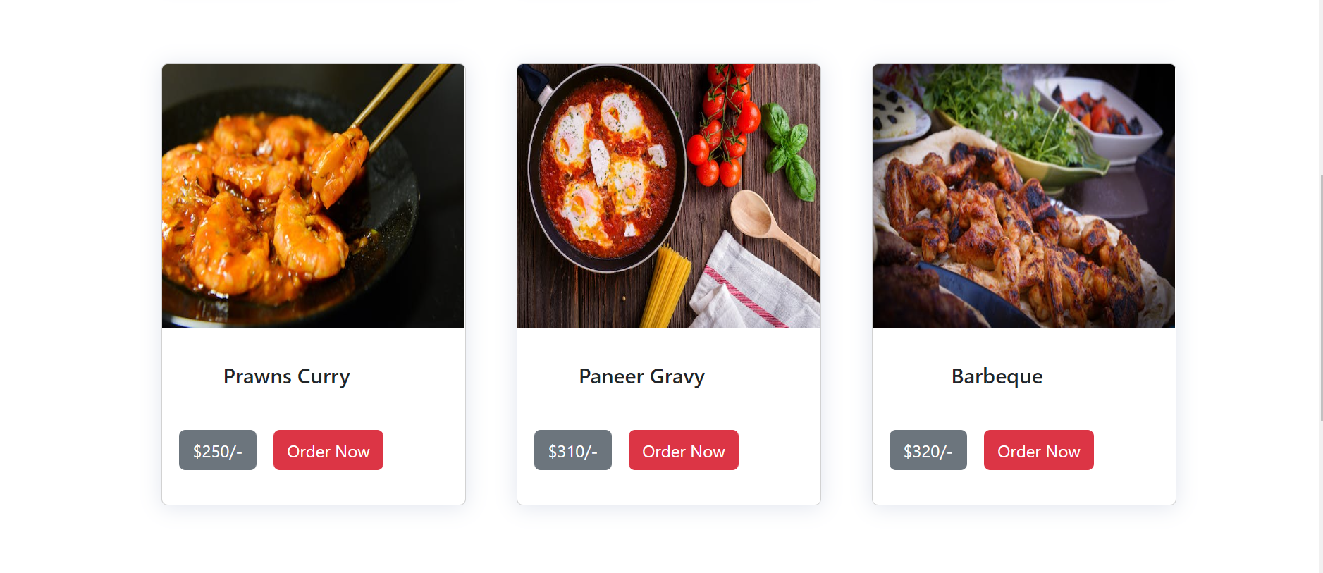

**CONTACT PAGE:**

